North Adelaide Croquet Club Newsletter
January-April 2021
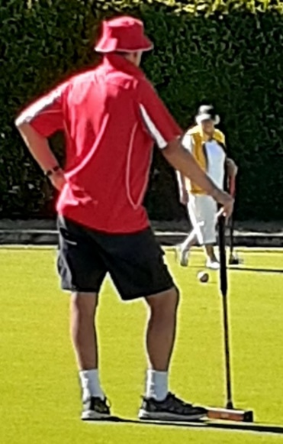
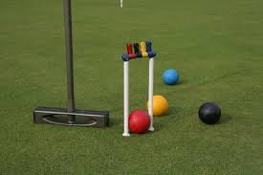

Editorial- Barry Elsey
Pandemic impact on the club
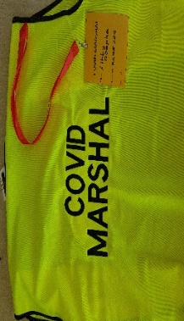
Looking back to 2020, we were all affected by the coronavirus pandemic, thankfully without more than some personal inconvenience and a period of ‘lockdown’ when we were not allowed to play croquet. I shall always remember the ritual of washing and disinfecting the croquet balls and hoops. It was surely an over-the-top reaction of the health authorities but also a reminder of how easily infection is transmitted and caught. Such situations often bring on a one-size-fits-all management, but the club kept alive its capacity to discuss and debate the restrictions imposed without much rancour.
Club members were remarkably compliant, and we quickly learned to maintain social distance at coffee breaks in a typical good-natured way. Covid-marshals appeared and the prize for best dressed went to Libby for her snappy badge attire. Her fashion statement has since been adopted by other marshals. We took Covid-19 seriously but in a relaxed and bearable way, reflecting the comfortable spirit of the club members.

The Social Aspect
Remembering the impact of Covid-19 in the NACC, is to be reminded of people enjoying the company of others. The regular wine-downs are a prime example. The social highlight is the annual Xmas lunch, which is always well attended, and a happy event shared by many. The Sunday bar opening twice each month could do with more participants, if only to break the monotony for Dan who turns up on the dot and sits out the two hours on his lonesome if nobody attends. Occasionally it provides an ideal opportunity for me to invite friends and university colleagues for a relaxing Sunday of play and chat. Our reputation as an open and friendly club with wonderful courts is widely known. Thank you, Dan and other members that produce such a convivial club (Badger and mallet) culture.
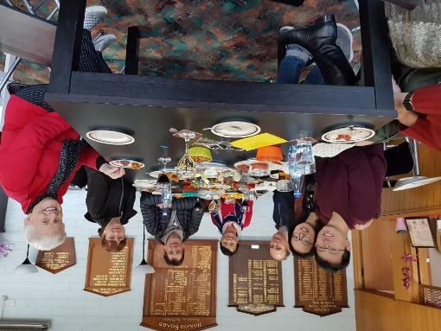
At a Sunday bar opening, Xmas in July was suggested by Teresa (from sunny Italy) and English husband John (a Chelsea supporter). We were joined by Kevin and Daisy, now also first-time parents with baby Yi Chen. Libby was resting between Covid marshal duties.

The strength of the club undoubtedly springs from members being willing to volunteer extra time and considerable effort in running the bar, organising wine-downs and numerous other activities that keeps the place looking clean and well managed. A special event in early December was official recognition by Prospect Council of the sterling work of volunteers. Our very own Lynn was there with a small support team to acknowledge her special role in the club. Lynn writes about the event a little further on in the newsletter.
Overseas and Local Visitors
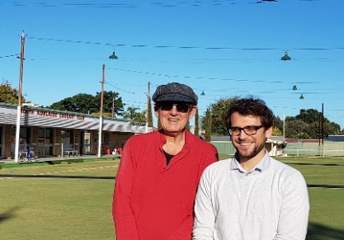
Since becoming a member, I have regularly invited visiting academics from many countries unfamiliar with croquet, to give it a go. Without exception they all liked the game (even the French!) and some have continued playing. For instance- Dr. Richard Muller from Karlsruhe Institute of Technology, Germany. Richard, like the four other young German academics I invited to play croquet, instantly loved the game and upon returning home bought a complete set to play on his parents’ lawn. Richard is now a first-time father, so his playing days are on hold. For the record, England beat Germany 6:4 before Richard returned home-so there!
The Club Attracts New Members
There are further reflections about the sociability of the club by both long-term and new members, which follow later. But of course, what brings us together is the pleasures of playing croquet. Clearly the club is attracting new members and that must be a welcome development. Our popularity will need to be managed, though, as we must ensure that everyone gets a game without over-crowding the excellently maintained courts. This is clearly a matter for the committee to address. The Wednesday evening playing option is a promising development. An extended Tuesday session is also being considered however, members will be informed if this is to occur.
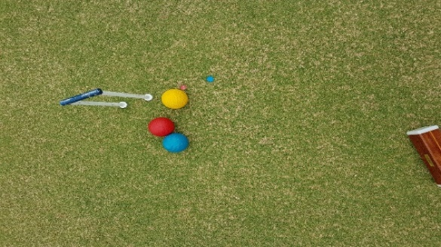
Golf croquet, a game for all talents on a level playing field.
On a related playing management matter, acknowledgement must be given to the considered attention Sue gives to balancing the games so that there is no player elitism, which would possibly create unwelcome divisions. Croquet should maintain its open access spirit with the mixing of playing abilities. There is always an opportunity for competition players to hone their skills in the second half of morning play. Experience and observation suggest the club thrives on striking a sensible balance about who plays with whom and we must thank Sue for her continued efforts.

The social importance of sports and outdoor recreation in Australia
In writing this editorial I was taken back in my memory bank visiting Budapest in Hungary in 1986. My colleague and I were the first foreign academics to give lectures at the university without providing notes to the security police. Surprisingly, we were invited to talk about the nature of civil society and the role of voluntary association. The thaw of the ‘Iron Curtain’ was slowly beginning in the late 1980s, which previously prevented just about any kind of civil society to emerge under Stalinism. However, we were followed by security people when we visited cultural houses to observe traditional folk dance and a tea appreciation society (yes!). Both activities were perfectly harmless but in the long tradition of state security, people might talk to foreigners! Can you imagine such an intrusion into our civil liberties in the NACC? We have much to be grateful for.
In writing this editorial, I was reminded just how important sport and games are in Australian society. People are playing something everywhere and it makes for a happy and healthy lifestyle. Despite the Covid-19 restrictions these voluntary activities and the civil society that provides underlying support, has re-emerged. The NACC is doing its bit to keep us healthy and sane.
Happy play and social times.
Barry
The History of the NACC
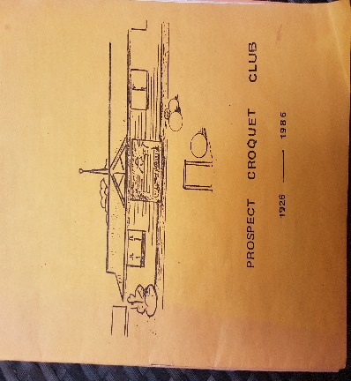
North Adelaide Croquet Club was asked to be part of a documentary film being made to commemorate the life and times of living in Prospect. Kay Seeary had agreed to be interviewed to give some of the history of the Prospect Croquet Club. At the last moment, because of an unfortunate accident, the president of the Prospect Local History Group was unable to complete the interview with Kay however, it has been deferred to a later date. This was a reminder that we ought as a club to ensure that we maintain a historical record of our club’s events. We have significant long-time members such as Colin Pickering, Kay Seeary, John Riches, David Wise, Glenda & Robert Kelly and many others from whom we can obtain the oral history. Together with this, photos, documents and shields have been relocated from the old club rooms to the current clubrooms, thanks to Ann & Gayle’s recent efforts. Photos have been placed on the walls around the bar area and pennant flags proudly displayed on the main wall. Have a look next time you are at the Club. Hopefully more to come.
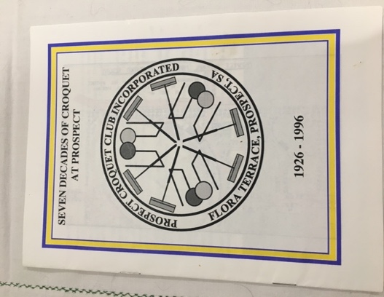
There are two publication attempts to write a history of the Prospect Croquet Club 1926-1986. Not surprisingly the record is mostly about competitions and playing personalities, together with brief mention of the foundation year in 1926.
A second document has been compiled ‘Seven Decades of Croquet at Prospect 1926-1996’. This publication gives a little more detail related to the development of the club membership together with skills, strength and achievements of the players as formidable opponents in SACA competitions.
There has not been any further documentation of important events in the Club since this publication so, perhaps it’s time. We are nearly 100 and we should consider what kind of historical record would best reflect who we are and the hallmarks of our existence as the North Adelaide Croquet Club since our amalgamation with Fitzroy Club in 2002.
The Voluntary Spirit
As noted in the editorial, Lynn Hughes received an award for her widely appreciated voluntary effort in support of club social as well as croquet competitions. Lynn would be the first to acknowledge other club members who one way and another contribute to the well-being and maintenance of the club; spring cleaning the rooms and external areas, running the bar, keeping the rose garden in pristine condition and, of course, the playing courts with line marking, edge mowing and many other activities that make us the envy of other clubs. Maybe we should consider calling the club ‘The Royal NACC’ with such splendid grounds!
Lynn has this to write about her recognition, which was a Prospect Council event in December 2020.
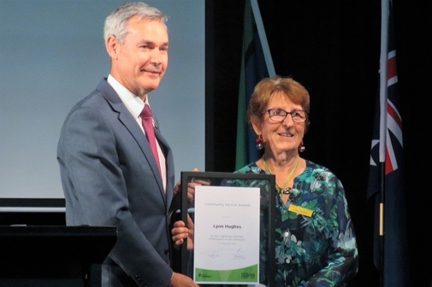
“I was lucky to receive the award. The event was attended by six club members and we enjoyed the whole evening, which continued at the local Thai restaurant. I want to thank Sue for nominating me. It’s something you don’t expect or even think about, but it was lovely to be acknowledged. I would especially like to thank Kath, Jocelyn and Libby for their help with wine-down evenings.
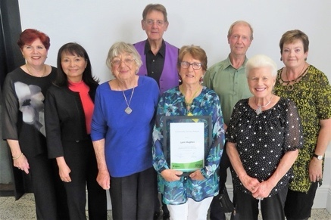
In January, I was invited to a cocktail evening by Prospect Council. Kath joined me. The occasion celebrated the work of volunteers in the community, the highlight being the award for citizen of the year awards.
We are all fortunate to be members of an active club, both socially and competitively in both codes of croquet. We benefit from a nice club atmosphere and I want to keep playing my part in keeping the club that way for as long as I can”.

The Badger and Mallet, your club, your bar- from Doc
Dear all, what a busy time it has been since I last typed! A big thanks to Peter, William and Tamara for all the support provided.
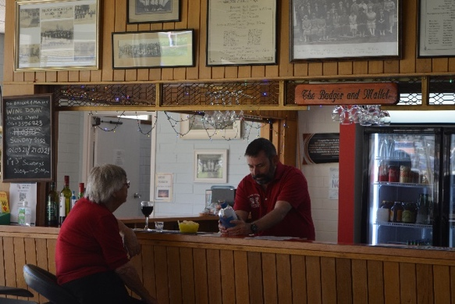
With Winter just around the corner - I think of those warm comforting drinks, the ones that take you to that special place! Yes, Snake bite (because after a couple the next morning you feel as if you have been bitten by a rather noxious snake) - the Badger and Mallet can make with either Irish whiskey or Scotch - see your friendly barman for advice. At the BaM we have a rather nifty range of non-alcoholic drinks including beer and a now a spirit which tastes like gin! Give it a shot if you are on the dry.
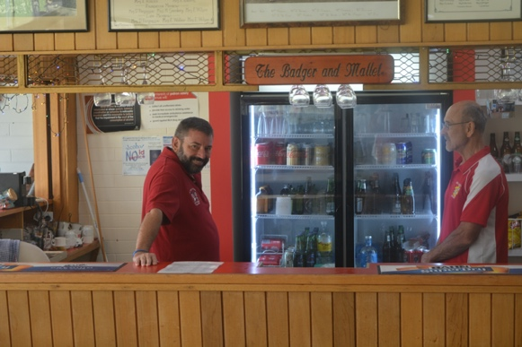

A man walks into a medical clinic and says to the receptionist “I have a doctor’s appointment “
“Which doctor?” she enquired. “No just a normal one will do”.

(Editor- I collect jokes to send to my grandchildren in the UK. This one is bound to rock them).
Member’s reflections of croquet and club membership
At the time of writing the editorial four members sent in their reflections, Chris, Di, John and Iain. Rather than report each individual response in detail it is reasonable to highlight some of their thoughts and experiences.
Chris Dazell is one of our newest club members, sometimes bringing along his wife Evelyn and son Daniel to play golf croquet. Chris is making rapid progress and already game for competitive events. Chris has only played golf croquet and plans to move to AC in due course.
It took Chris two years to decide to join the club. Since then, Chris has been a regular player. A big part of the attraction is the friendliness and warmth of members as well as the competitive spirit.
Chris enjoys being an active member and volunteers to help William and the ground maintenance crew (which includes other jump shot players!).
In the ‘room for improvement’ section Chris seeks more single play opportunity to practice for inter-club competition. He also recommends that the committee explore the possible-maybe of advance booking playing times.
Di Wall has commented in the previous newsletter and adds that she has been a member for four years having played previously in another club. A decisive attraction to join the NACC was the better facilities, like parking and club rooms and, of special note, the “very special Kay Seeary”.
For Di the attraction of golf croquet is “because it flows, no stopping and starting. I like to play a tactical game and that makes life interesting when playing GC. I think playing GC has improved my AC game”.
Di also notes something else of importance “Association is also a game of tactics; however, I play it less frequently now because age makes my joints complain with all the bending (for take-offs) and climbing from the lawn to the verandah-sitting and standing numerous times within a game is painful”.
Di has one special memory of earning a wooden spoon at a Gala Day and while thanking everyone for a prize she had not expected heard the cry amid much laughter ‘You lost!’ In fact, her response had other happy memories of competitions, mostly lost, but gamely played.
Di enjoys the social activities, notably wine down, for the convivial gathering and easy conversation.
Finally, Di appreciates the work of the committee and others that volunteer to keep the club running smoothly. She is aware of the risk of over-crowding and asks that the committee explore ways and means of managing the emerging problem before it gets too big.
Iain Fraser is another long-time member and informs us that he was part of the merger of Fitzroy and Prospect, becoming first president of NACC. Iain is mostly an AC player, which he also regards as more challenging.
John Riches is another experienced croquet player, mostly AC which he finds more complex and challenging. John has been a NACC for over 15 years having learned to play previously at Port Pirie under the guidance of David Wise. Before the NACC John played at the Broadview club, which no longer exists.
John is an ‘unsung hero’ as in his response to the survey, informed us that he was a recognised coach and once accepted an all-expenses paid visit to the USA to coach croquet. John has written books on croquet and was previously a coaching member at SACA as well as past president.
John concludes his reflections by praising the quality of the playing courts and the friendliness of club members.
(Editor- I certainly found it interesting to obtain these snippets of the life and times of the NACC and earlier clubs, together with the views and experiences of members. I shall continue to seek more for future newsletters).

Reports from The Playing Fields
Association Croquet Roger Harris Captain, AC
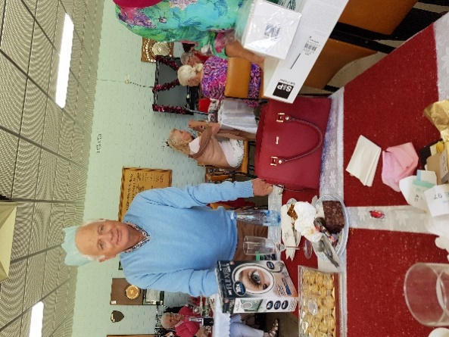
A number of competitions and tournaments have been held in Association Croquet involving our Club. There is good news to share!
2020 Presentation Day was held on 12/2/2021 at Norwood Club
- North Adelaide – won the AC Div. 3 Saturday Pennants
- Combined North Adelaide and Salisbury team (“Northbury”) – won the AC Night Doubles Div. 64+
- Combined Norwood and North Adelaide team – won the AC Div. 4 Saturday Pennants
- Roger Harris was presented with the J. F. Harvey Bronze MedaI (for the second year)
Completed 2021 competitions
- Div. 3 Night Doubles 2021 (teams of two)
1st: Salisbury (3 matches, 22 points)
2nd: NACC White (3 matches, 21 points)
3rd: NACC Red (0 matches)
- Div. 2 Night Doubles 2021 (teams of four)
4th NACC (17 pts.), after two Norwood teams (54 and 39 pts.) and Hyde Park (22 pts.)
NACC teams for 2021 have been registered with SACA for:
- Weekend Pennants (Mar – Nov) – Div. 2, Div. 3 and Div. 4 (with West Lakes)
- Sunday Fundays (starting April after Easter) – Div. 2, Div. 3 and Div. 4 (with West Lakes)
Intra-club play
It has been great to have our AC numbers augmented over the past few months with the four keen players who have joined our Club from Tea Tree Gully Club: Russell Kopp, Lyn Booth, Ray Walter and Barbara Stanley. We warmly welcome them to our club. With several players who join us from Norwood as associate members on each Thursday morning, we now have around 14-16 turning up to play, while on Saturday afternoons we have around 10-12 playing.
Visit to the Gold Coast 6 - 14 March 2021
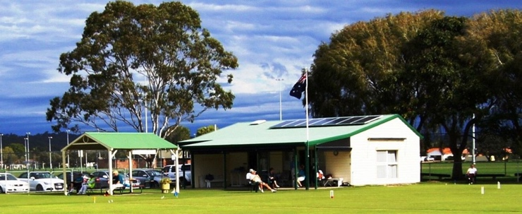
My wife and I journeyed last week to stay with friends in Palm Beach, Gold Coast. One day (Tuesday afternoon) I wandered across the road to the Burleigh Heads Palm Beach (BHPB) Croquet Club and, while watching over the fence, was warmly greeted by John who was one of a group playing golf croquet. He invited me in, I was given a mallet and ended up playing four games with various combinations of people during the rather hot afternoon. Green fee was $7 which I duly paid to the Treasurer Ken Thompson. The club was formed in 1950 and currently plays three codes of croquet – though I was informed that their numbers playing AC were very small. Burleigh Heads club merged with Palm Beach, as apparently the caravan park in Burleigh Heads required more land, so they moved a little further south to Palm Beach where there are three courts. There are four clubs on the Gold Coast: Southport, Broadbeach, BHPB and Tweed Heads.
The photo is of the Clubhouse, with extensive fields for cricket, touch rugby and soccer (home of the Palm Beach Sharks) and courts for netball and basketball in the background.

Golf Croquet at North Adelaide Croquet Club Sue LePoidevin, Captain
- Golf Croquet is flourishing at NACC. Our club has over 70 members and many of them are Golf Croquet players. As Golf Croquet Captain it is my responsibility to structure play on club days on Tuesdays and Saturdays. This involves making sure that players rotate over all lawns and play with different members so that everyone gets a fair turn. After Morning Tea, I try to give team members an opportunity to play together wherever possible. I also manage the registration, organization and support for our competitive teams. This year we have: -
- 1 Open Team competing in Autumn night time Pennants and on weekends over the entire year
- 2 6+ Teams also competing in night time Autumn Pennants and on weekends over the entire year
- 2 9+ Teams competing at night and on weekends
- 2 24+ teams competing on Mondays through autumn. (24+ means that the 4 players must have Handicaps adding up to 24 or more i.e. a 4, a 5 a 7 and an 8)
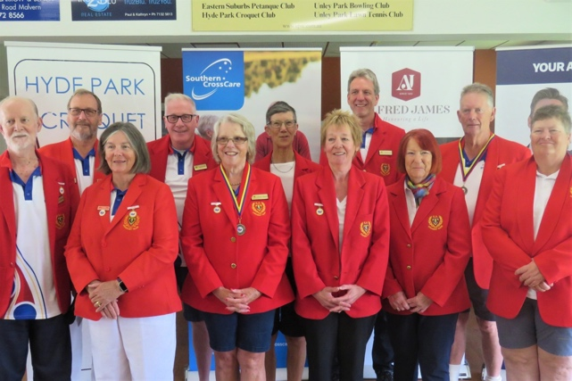
Regular coaching has been provided this year by Noel Spooner for the 6+ Red Team and the 24+ teams and by Norma Greig for the 9+ Teams. We are very appreciative of this coaching as it has made a big difference to our standard of play.

Congratulations to Norma Greig who has been selected in the South Australian State Croquet Team. We are very proud of you, Norma.

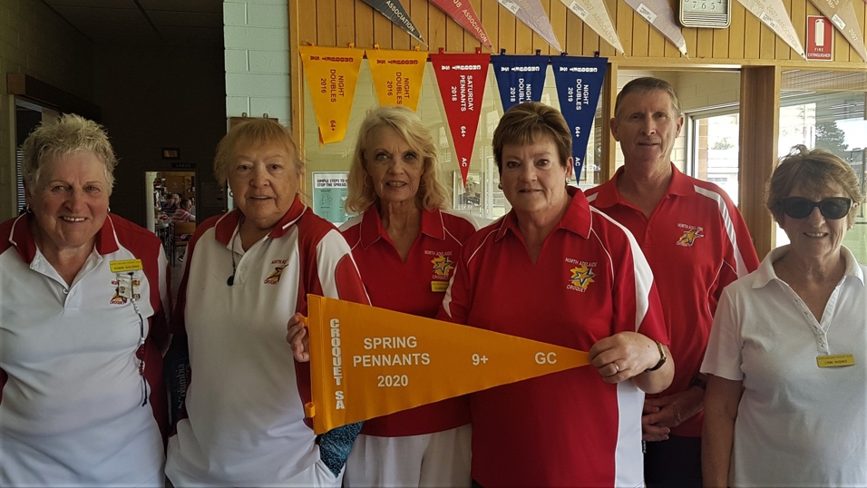

Congratulations also go to the North Adelaide Strikers 9+ Team which won the Spring Pennants in 2020. They were presented with their Pennant at the Hyde Park Croquet Club.

Reports About Club Management and Maintenance
Club Grounds: William
The Club had a busy period in late summer getting the grounds and courts ready for a heavy competition season ahead. We had a happy band participating in our working bee to finish covering our court I canopy and to make extra provisions for hanging up pennants and photos etc in the Clubrooms (thanks David and Ann).
There has also been painting, gardening and cleaning to get ready for Gala day. Everyone involved has been very efficient and happy – we need many hands to look after a large Club premises like ours - to be the envy of other clubs.
I am happy to report that a couple of our new Members (Chris, Daniel and Jim) have been assisting me with line making - many thanks to them for their quick learning and help. Good to see also that newer Members are taking the challenge to set up hoops which is helpful to everyone.
We have been fortunate to have a mild summer which as meant less distress for our lawns and fewer lawn beetles. There is a leaky pipe at court 1 which is causing mounding and we are keeping a close eye on it.

Treasury: Kay McTavish-Cooke
The NACC finances are in a reasonably good position, thanks to the hard work of members who give their time freely and often to make our club the great one that it is, your contributions are greatly appreciated. Too many to name individually, but you know who you are.
It is so good to see so many members have taken to the new uniforms, it looks good to see a sea of red when playing. I believe other clubs have also commented favourably.
Just a reminder for the members who pay their subs quarterly, membership fees are again due, thank you.

Special Events
North Adelaide Croquet Club Gala Day on 19th March-
The NACC is remarkably adept at staging special events, which invariably call upon the organisational and catering skills of several members. Sue testifies to this spirit of competence and confidence below. The club is quick to recognise and acknowledge the special contribution of members who volunteered their time and effort. Sue writes in praise of the event and its volunteer supporters-
Gala Day Thank You
Gala Day on Friday 19/3/21 was a huge success for the game of Croquet but also in showcasing what our club is capable of. Kevin and I both received many comments and emails from players thanking our club for a great day. It was only achievable through the dedication and generosity of many club members. I would like to thank all of the food providers: - Ines, Kath, Joan, Libby, Mary, Chris, Eleanor, Tina, Gayle, Marie-Ann, Pam, Janice, Norma, Claire, Elizabeth, Heather, Sandra, Barbara, Lynn Hughes, Ray, Ann, Jean, Jocelyn and Jane. The home-made food was delicious and of a very high standard and was complemented by a selection of bought food. It was a great team effort.
Thank You to the members who donated money. This was used to purchase Costco sandwiches, a large Quiche from Prices’ Bakery, soup rolls, cocktail pasties, fruit for a fruit platter and a Pavlova shell.
A massive amount of work was done on the day. Kevin, Noel, Jim and Gayle ran the games expertly and kept to time very well. Gayle and Jim, and later Chris, had to fill in for a player who didn’t turn up and the wonderful Rossie agreed to play at 9:30p.m. the night before when another player pulled out. Marie-Ann and Monika helped get the day underway by early organisational tasks and Tamara managed the raffle. Dan and Peter capably attended to the drinks side of things.
But the hardest part of all was getting the lunch prepared and out on the tables in time. That task was very capably managed by Joan, Jean, Barbara, Tina, Eleanor and Kath. They worked like Trojans in the kitchen. It was very hot in there but they did a wonderful job preparing and serving the meal with a friendly smile. Jane assisted with the soup.
At the end of the day Jocelyn and Elizabeth managed the Afternoon Tea and the packing up.
What a fabulous team effort. I felt very proud to be a member of the North Adelaide Croquet Club. Sincere Thanks to everyone involved.
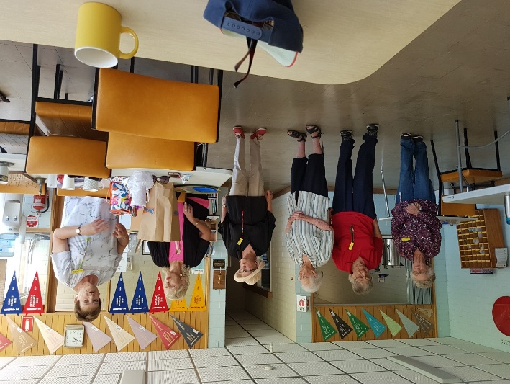
Sue LePoidevin

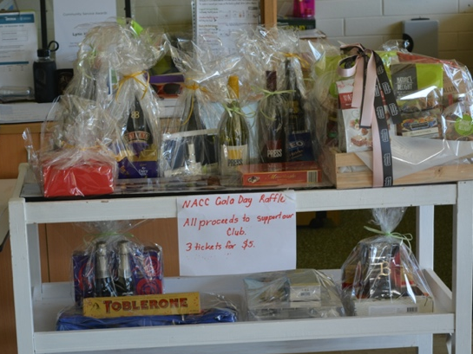
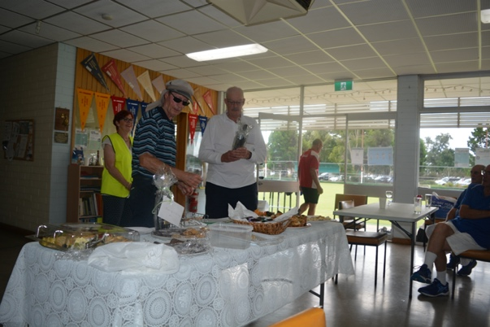
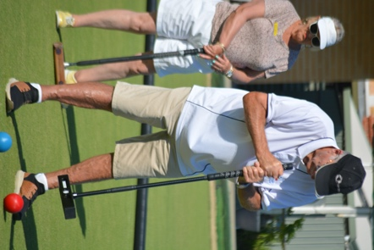
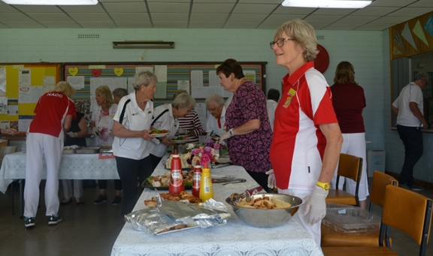
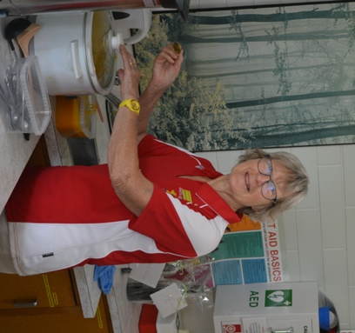
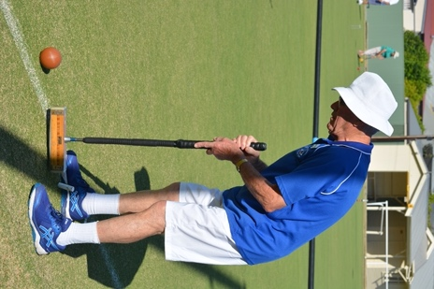

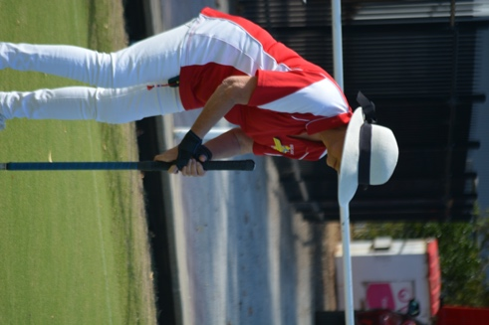
A few highlights
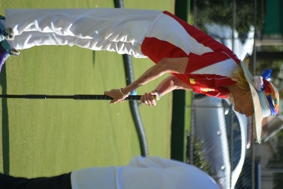
from Gala Day

